Latihan Soal Pertemuan 9
Muhammad Andhany Bahar / 20
TI-1C

- Latihan 1

- Flowchart
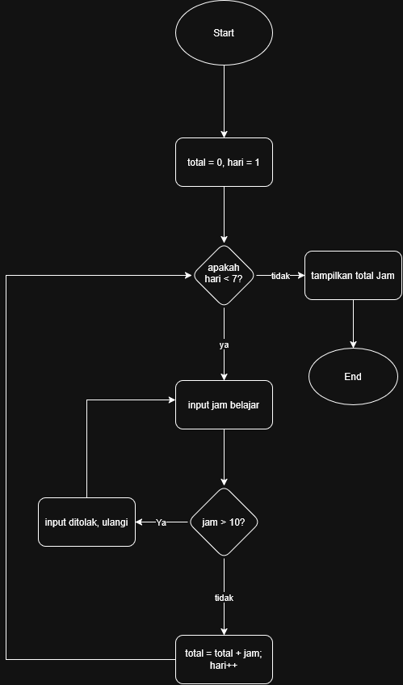

- Pseudocode
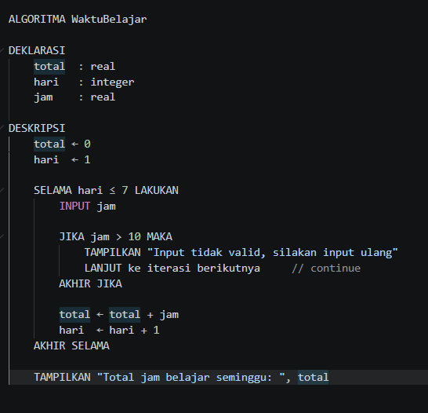

- Program Java
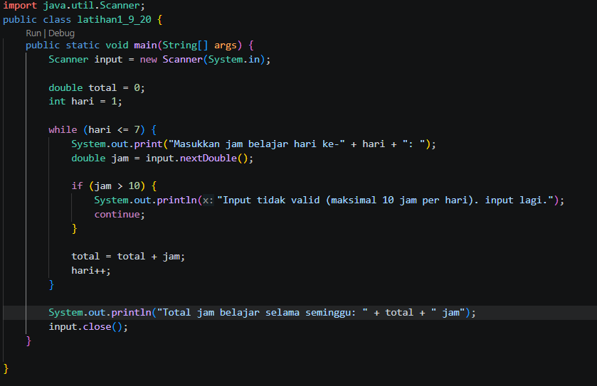

- Latihan 2

- Flowchart
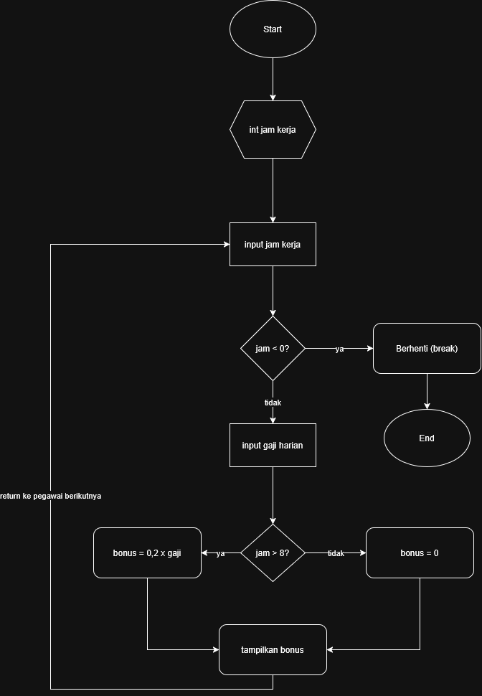

- Pseudocode
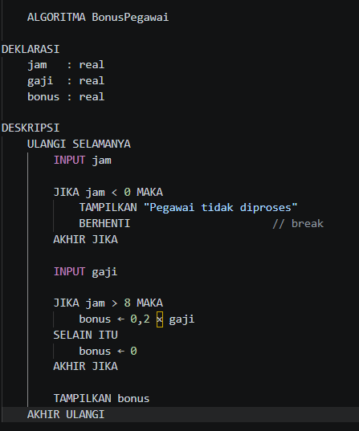

- Program Java
